AGENDA – DRAFT!!!
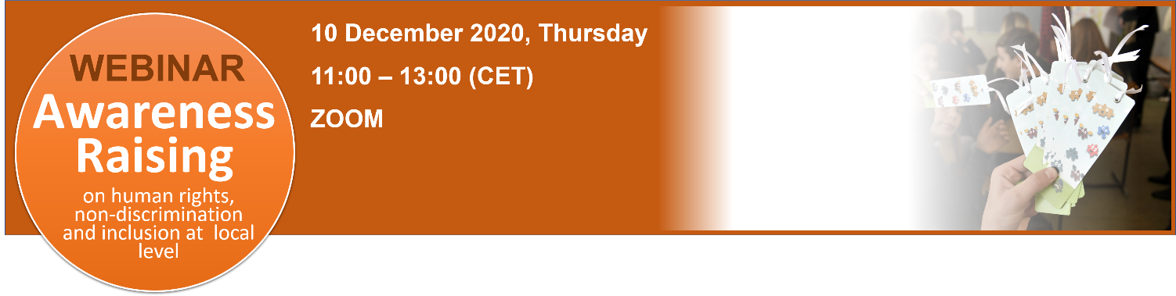
Link to the Webinar registration: https://zoom.us/webinar/register/WN_AQQfw5rLRcuz_A1DE45EUQ

AWARENESS RAISING: human rights, non-discrimination and inclusion at local level
Time | Session
10:45 – 11:05 | Check-in of Participants and instructions on Zoom Webinar features
11:05 – 11:15 | Welcome by the Standing Conference of Towns and Municipalities, GIZ and NALAS  Bad Words Series  Video | Mirjana Komnenović – SCTM Project Coordinator  Igor Miskovic – GIZ BA  Boran Ivanoski – NALAS Programme Officer  https://www.youtube.com/watch?v=1wxb4Ak1iz4
11:15 – 11:25 | First participant interaction  Opinion poll – Quiz
11:25 – 11:40 | AWARENESS RAISING - human rights, non-discrimination and inclusion at local level  Presentation | Slavica Biljarska Mircheski – Expert
11:40 – 11:50 | Youth Center "Vermont", Brcko, Bosnia and Herzegovina  Presentation – good practice | Ferida Meškovic - Project Associate
11:50 – 12:00 | Municipality of Raska, Serbia  Presentation – good practice | Srdjan Vasiljevic – Municipality of Raska, Serbia
12:00 – 12:10 | Break
12:10 – 12:15 | TBI  Video
12:15 – 12:45 | Awareness Raising – challenges  Virtual Panel Discussion | Ferida Meškovic  Slavica Biljarska Mircheski  Srdjan Vasiljevic
12:45 – 12:55 | Q&A with participants
12:55 – 13:05 | Project expected results and benefits for the municipalities | Boran Ivanoski
13:05-13:10 | End of the Webinar

